Genetic Algorithm For Single objective and NSGA-III for Multi_objective:

Both are Optimization technique, but they differ significantly in their mathematical formulation and objectiveas.

Genetic Algorithm: GA’s is typically used for single objective optimization problems, to find the single optimal solution. In GA each individuals in population evaluated based on the single objective function. Various selection methods such as roulette wheel selection, tournament selection, rank-based selection are used to choose individual for reproduction based on their fitness values.

In single-objective GAs, sorting is typically done based on the fitness values, with the best individuals ranked higher. The mathematical operations in GAs are relatively straightforward, involving selection, crossover, and mutation based on fitness values. The complexity primarily depends on the population size and the nature of the crossover/mutation operators.

NSGA : NSGA-III is designed for multi-objective optimization, specifically for problems with more than two objectives. The goal is to find a set of Pareto-optimal solutions that represent trade-offs among the multiple objectives. it uses a Pareto dominance approach where solutions are compared based on multiple objectives. Individuals are sorted into different fronts based on dominance levels. The selection process in NSGA-III also incorporates niche preservation, ensuring that solutions close to each reference point are selected.

NSGA-III explicitly maintains diversity using a combination of reference points and a niching strategy. NSGA-III uses a non-dominated sorting mechanism where individuals are ranked based on Pareto dominance. The sorting and ranking processes are also more involved due to the need to handle Pareto fronts and niche preservation.

the goal of multi-objective optimization problems is not to find the best (single) optimal solution, but to find the so-called Pareto front, which represents the trade-off between objective function values

1. Individuals are ranked based on the dominance of their objective values, and selected to survive from the top rank.
2. When the predefined number of individuals to survive is not exactly fulfilled, the rest of individuals are selected based on so-called crowding distance, a measure which aims to ensure diversity.

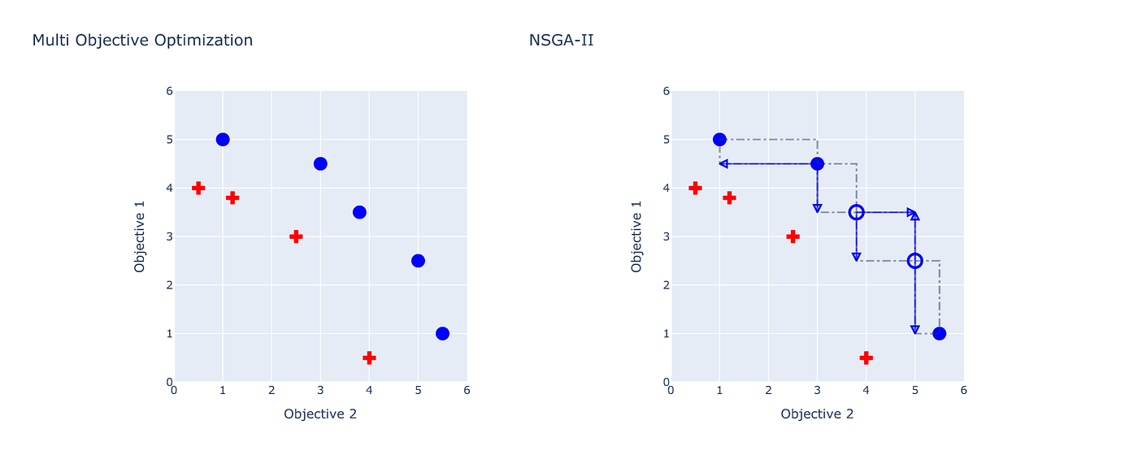

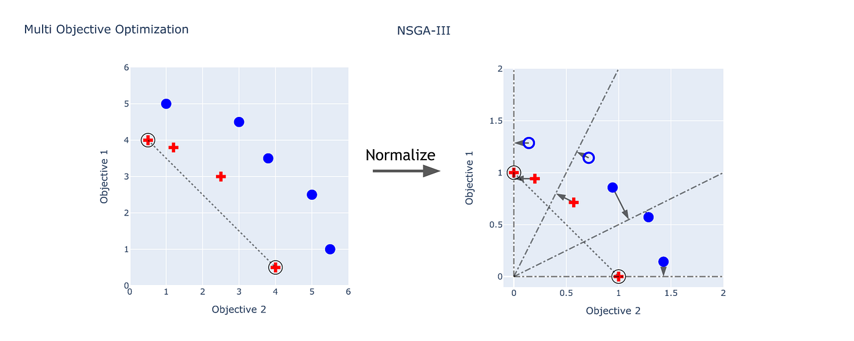

 The red points represent the individuals in the Pareto front, while the blue points and circles represent the individuals in the borderline front. The points indicate the selected individuals by each algorithm, while the circles represent the individuals that were not selected.

1. NSGA-III does not use any explicit selection operator on Pt in the process of creating Qt. On the other hand NSGA-II’s selection operator uses non-dominated rank and a crowd- ing distance value to choose a winner between two feasible individuals from Pt. It is worth noting however that, NSGA-III performs selection if and only if at least one of the two indi- viduals being compared is infeasible. In that case NSGA-III prefers feasible over infeasible, and less violating over more violating individuals.
2. NSGA-III uses a set of reference directions to maintain diversity among solutions, while NSGA-II uses a more adaptive scheme through its crowding distance operator for the same purpose

**Key Steps in NSGA-III:**

1. **Initialization**: Start with a randomly generated population.
2. **Non-dominated Sorting**: Sort the population into different fronts based on Pareto dominance. The first front contains non-dominated solutions, the second front is dominated by the first, and so on.
3. **Selection with Reference Points**: Use predefined reference points in the objective space to guide the selection process. Solutions close to these points are given preference to ensure diversity.
4. **Crossover and Mutation**: Apply crossover and mutation operators to create new offspring.
5. **Environmental Selection**: Select the next generation by combining parents and offspring, sorting by non-dominated fronts, and using reference points to maintain diversity.
6. **Termination**: Repeat the above steps until the stopping criterion is met.

* The Pareto front (or Pareto frontier) is a concept in multi-objective optimization that represents the set of optimal solutions where no single objective can be improved without worsening at least one other objective.

This ensures that the algorithm finds a wide range of trade-offs between conflicting objectives, even in problems with many objectives.